Fun Chinese Website

Website name: [www.fun-chinese.com](http://www.fun-chinese.com)

Name:

Fun Chinese Language Studio 趣味汉语

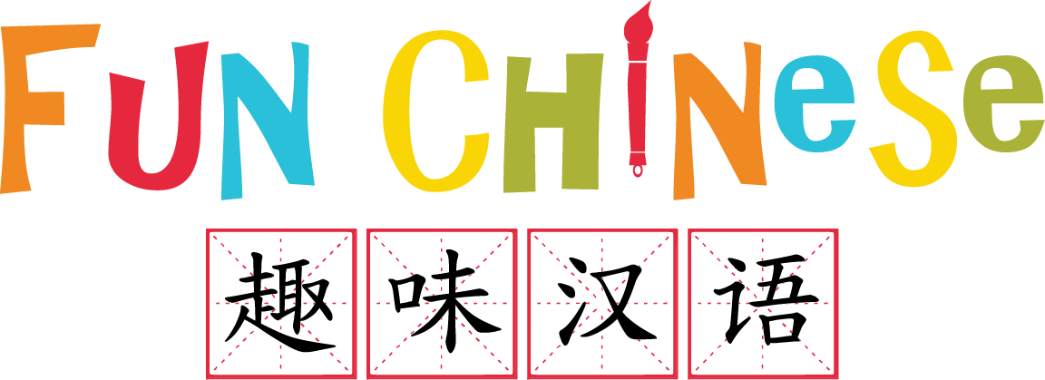

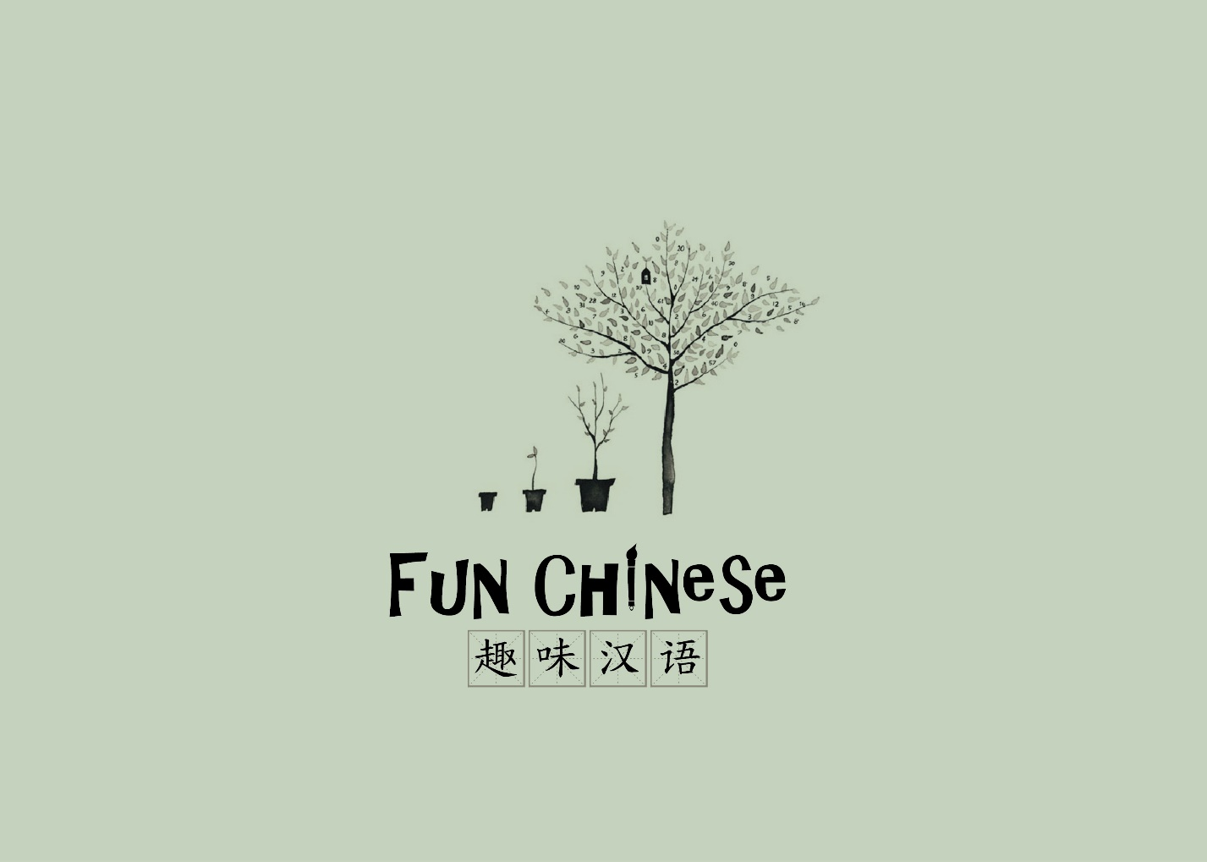

Welcome! Fun Chinese Language Studio offers small classes in a nurturing and supportive environment where children can learn Mandarin through interactive reading activities, hands on projects and fun games. Learn more. (link to programs).

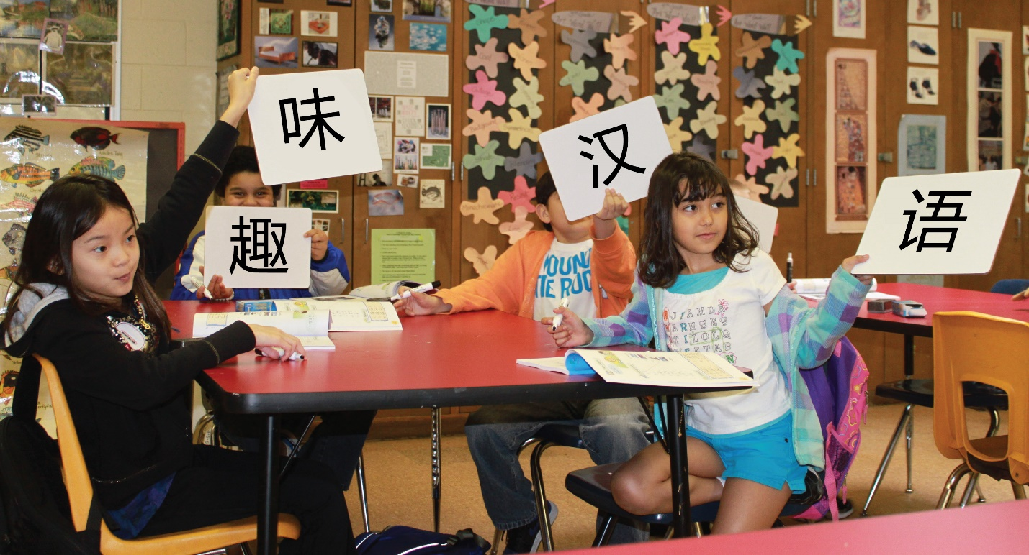

Why Study Chinese?

为什么学习中文与中国文化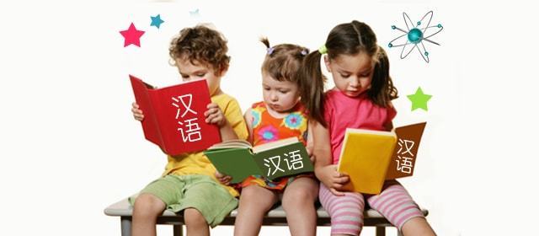

**Why Mandarin?**

My question to you is “why not?”  Mandarin Chinese is the most widely spoken language in the world. Learning Chinese gets more important as China continues to grow and take important place among the world's powers. The opportunities for Chinese speakers are becoming limitless.  Kids who learn Chinese will put themselves at the top of the multilingual list. All experts agree that learning Chinese is much easier in childhood than adulthood. Actually, this is true for all languages, but more so for Mandarin Chinese, because it is a tonal language. In a tonal language, like Chinese, the same words can be pronounced in completely different ways. Learning how to do this for a non-native person is easier in childhood.

**What Are the Advantages of Learning Chinese For A Child?**

Apart from better career prospects when he or she turns adult, child benefits in many ways if they learn Chinese as a second language. Two most important benefits are:

* Creative thinking –Research shows that learning Chinese helps stimulate cognitive growth in young children, besides activating the development of both sides of the brain.
* Motor skills – Chinese is written in a different way, allowing children to develop better motor skills.

**Why Choose Fun Chinese**

* Fun Chinese offers **small classes** from 3-6 students per class. The **small teacher student ratio** in the class can give all the help and attention kids need. They are not only taught to learn, **but most importantly, to love to learn.**
* Fun Chinese designs **developmentally appropriate curriculum** according to children’s cognitive development stages to achieve personalized education.
* Instead of teaching Chinese, Fun Chinese is designed to give students the opportunity to engage in **independent/child-directed activities** to stimulate children’s interests in learning Chinese
* Through age appropriate interactive readings, games, songs, stories/poems and other fun activities to let children **learn Chinese while having fun**.

Come join Fun Chinese and learn Mandarin in a fun and highly focused environment. You won't regret it.

Programs:

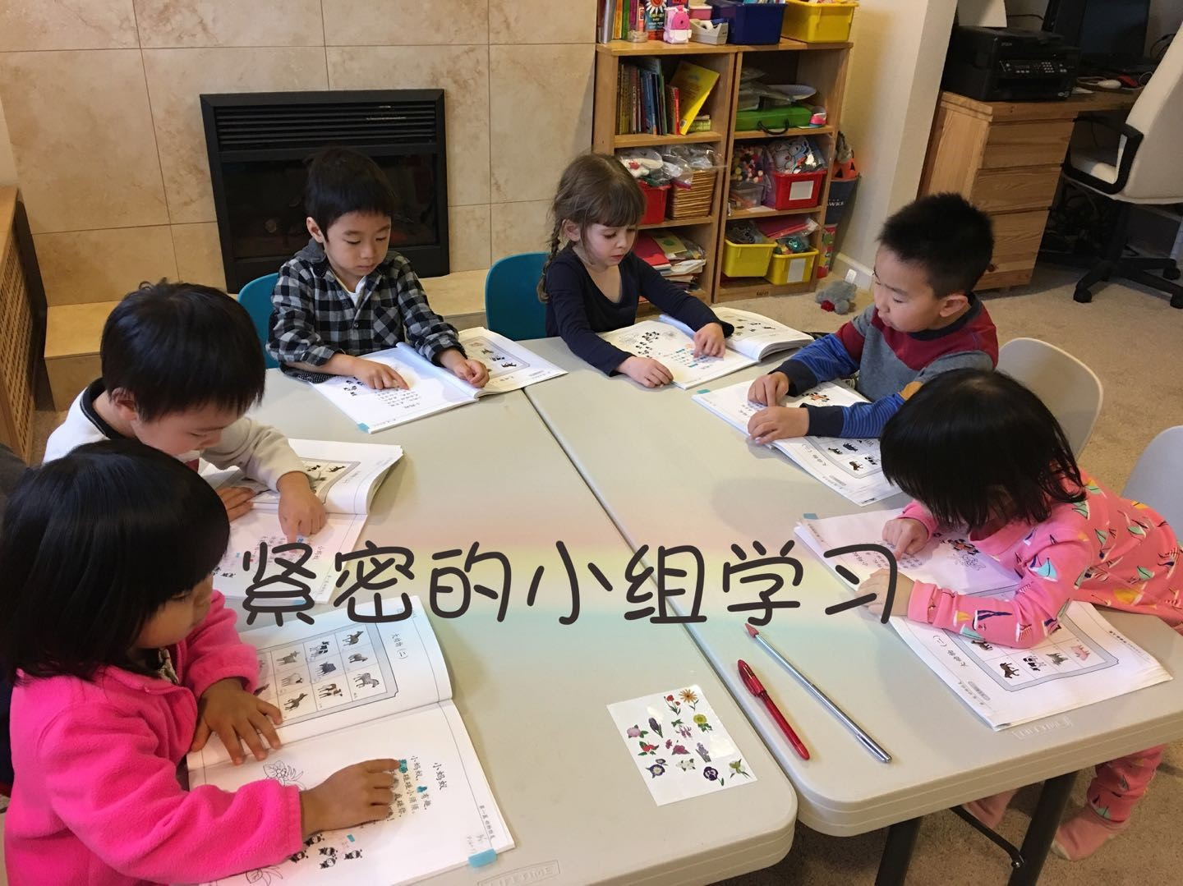

By involving both Chinese and U.S. teaching methods and culture, Fun Chinese Language Studio customize the curriculum and tailor-made programs that will fulfill the short-term goal and long-term goal for the international young learners ages of 3-13.

Afterschool and weekend Chinese Language classes for ages 3-13

**First Chinese (Basic Level):** This class is for beginner level young learns. To hear and to reproduce the critical sounds and tonal differences in Mandarin. Throughout the course, young learners will naturally acquire Mandarin through songs & rhymes, stories, poem, etc. Students participate in interactive reading activities and fun games by utilizing Chinese with the culture practices in a natural setting. we will also be introducing basic Chinese characters recognition.

**Fun Chinese (Intermediate Level):** The class is a carefully structured Chinese language class for early young learners. This course focuses on strengthening students’ daily conversation and reading skills. Kids will also be guided to do more role play activities using longer phrases and learn how to ask questions in Mandarin. All types of teaching/learning methods and fun activities for the young learners to be enriched for Chinese learning. we will also be introducing Chinese character writing.

* It is suggested that child with no Mandarin background can sign up for **First Chinese** courses.

**Smart Chinese (Advanced Level):** The course will be of similar standard to Chinese native speaking children for their Chinese learning while the oral learning will be much focused in class. Chinse Writing will also be taught in this class, such as explanation articles, short essay crafting, and free creative writing and so on. A normal class is 70% for oral practice related to reading/storytelling, class discussions, etc. 30% for the written format practice. Reading and writing homework will be assigned regularly in this class.

* It is suggested that children with no Mandarin background should go through the basic courses, such as **First Chinese** and **Fun Chinese**.

**Register Now:**

**Try a free class: New students are welcome to attend a free trial class! Click Here to register.**

About us:

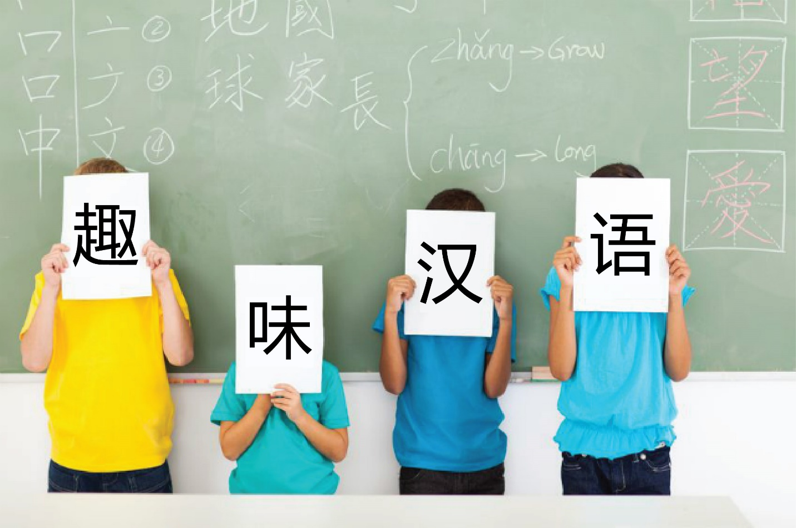

Fun Chinese was founded in 2014. FC specializes in offering Chinese language classes to students from age 3-13. It is aimed to facilitate and promote world language acquisition for students who wish to have a head start in learning a second language before high school and college. It has gained its reputation through high academic quality and fun activities to ease acquiring languages for children, youth and adults. Currently the program is running as an after-school program and weekend classes.

Our goal is to make second language classes not only accessible but also effective and fun.

What We do

* To create a well-balanced Mandarin curriculum for young learners who grow up in America.
* Provide an engaging, fun and supportive learning space
* Create entertaining and interactive learning experiences
* Encourage respect for all people
* Instill pride for your own culture

How we think

Learning Chinese does not mean abandoning your child's English. Bilingual children are more sensitive to language and can master it better. Children should be encouraged to speak Chinese, but not compelled.

Teaching Chinese through hands-on interactive activities can lead to better teaching results. Follow the guidance of development of young children, adopting children’s whole body in fun activities can better cultivate children's interest in learning language and let children learn through play.

学习中文并不意味着摒弃孩子的英文，相反，双语的孩子应该对英文更敏感，把英文掌握的更好。要鼓励孩子讲中文，但不能强迫。

寓教于乐学语言，能收到更好的教学效果。根据儿童成长发育的特点，采取“调动全身学习语言”的教学方式，能更好的培养孩子对学习中文的兴趣，让孩子在玩中学。

Contact Us:

Fun Chinese Language Studio

Address: 14510 20th St #202 #203, Bellevue WA 98007

Email: funchinese@outlook.com

Write to us:

